The Voree Plates
Translated by James J. Strang and
Retranslated by Seer Samuel Warren Shaffer
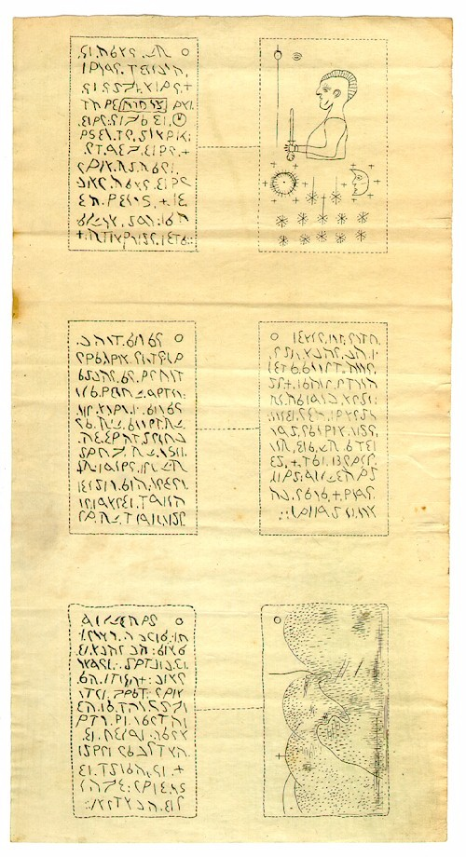
The Book of Raginel
PLATE ONE

1. Behold my people are no more. I am their King and mine mighty warriors are fallen, and the young are slain in battle.
2. Verily their bones are strewn and lay bleached on the plains. Mine people did fight at Magali, yea they did fight the shadow that did engulf the land in a second darkness.
3. Even the noon day is like a shadow. For the house of the inferior race even those made of dust and mud do fill the land.
4. The walls are cast down insomuch that the moat is filled and one can pass over into the ruins unhindered. They shall not be again inhabited for the children of darkness do not have the skill to raise them. And even if they could it would be a den of evil.
5. Behold mine name is Raginel Manchal and I have alone escaped to bury the princes in the wilderness, and even the Prophet Zelph did I bury in Magali.
6. And now their bones which are strewn in the ruins are even broken and stepped upon by the forces of darkness, but behold it mattereth not for their spirits are gone from them and they feel not pain but are trained in the halls of Daanel.
7. And now the Sun rises and I know that the darkness can never dwell there, for the darkness hateth light and all darkness is destroyed and consumed by it, but this world is of the darkness, wherefore there is a constant cycle of darkness upon it.
8. Mine people do sleep in peace, and they are a power that is yet to be unleashed upon the world when the gates of Daanel are opened!
9. For in the last days they shall ride with the mighty, they shall direct the spears of the righteous, their axes shall cleave the skulls of the wicked.
10. And now wickedness can be circumscribed into only a few words, captivity of conscience and the fettering of free will, darkness and the impurity of race, yea even the pollution of intelligence, for the devil alone retards the minds of men.
11. May they dwell in peace with their fathers, some have not made their faith perfect but if they were on the road to enlightenment there I hope to meet them, for the faithful shall be exalted.
12. And now we do have a promise from the Gods, for they have sworn to give an inheritance unto the righteous and to disillusion those transgressors who embrace the darkness.
13. As I did hold mine Son Prince Eldarinor in mine arms and cried over him, I did hear the words of the Lord which came unto me in mine darkest hour, and this is what he said.
14. I shall avenge thee by the might of the destroyer, those who have done this unto thee shall have an hundred fold punishment.
15. And now they shall be driven out of this land by the tribes of the north and by a prince from across the deep that I have prepared in mine own wisdom.
16. And now those of these strangers who mix with the darkness unto the least degree shall be destroyed by the Israelites that are to come from across the sea after this Prince.
17. And now I shall set up an ensign unto all nations to call out to the escaped of mine people.
18. But behold the people shall reject this ensign and shall kill their shepherd and shall not build upon the Rock of Seership.
19. Wherefore I shall scatter mine people in that day and in three to four generations I shall raise up another to translate and to bring forth mine words.
PLATE ONE (Backside)
Facsimile

1. The all Seeing Eye, to the left of which is a solar scepter of Divine Kingship.
2. Raginel Manchal holding a short sword and wearing a Mohawk; it was revealed unto me that he being the only survivor met the Son of Madoc after depositing the plates, whose name was Mohonrik; and he teaching Mohonrik the mysteries of his people, Mohonrik went on to start the Mohawk Indian Tribe, which was a white tribe descended from Madoc.
3. A Solar dist with twenty eight emanations which is surrounded by six Tau representing anointed ones.
4. The Moon surrounded by six Tau representing six more anointed ones, in all with the Sun making a quorum of Anointed Apostles.
5. Twelve stars representing the quorum of the twelve Apostles and three emanations representing the first presidency of the Church emanating out of the quorum of the twelve.
6. Smaller stars surrounding the twelve representing the quorum of the seventy.
PLATE TWO

1. And now it shall come to pass in the last days that my people shall hear my voice oh Raginel and the truth shall speak from the earth, but few shall hear it, and even the rocks shall speak it.
2. Now behold those who shall come and build a temple shall be full of traditions and the temple shall save a few living and their dead, but it shall be filled with the powers of darkness, for a murderer shall sit as God in the Celestial room thereof.
3. And now the Prophet who shall show himself as God shall say peace, peace and there shall be no peace.
4. And now there shall even be a seer who shall find thy record in this place by his power, but he shall be a seer of darkness and shall have many traditions, wherefore the full account shall not be revealed unto him.
5. But behold he shall be a tool in mine hands, and your record shall be known at last in the very last days.
6. Now when I Raginel did hear these words my mind was comforted and I did walk through the forests in the falling rain to escape the armies of the dark ones, for the spring rain was over the whole land.
7. And now I have found a place of resort upon an Isle in the inland sea to the north, wherefore I have prayed to be preserved that I might finish my record and also write some few of mine teachings upon these plates, so that they may be preserved for future generations.
8. Now I shall talk somewhat about the Priesthood, for the Priesthood is a blessing of the fathers upon the heads of the children of the Gods.
9. For no unclean thing nor any creature or beast that is not a descendant of God and verily not a child of God shall be able to hold it.
10. And now we do have the rites of the fathers it being handed down unto us from Moroni, for verily we are descendants of Moroni and of the children of Odin who came unto this land.
11. And we have also mixed somewhat with the northern tribes who are descendants of the solar Gods from the red stars who are also white and delightsome, and we have kept our white racial integrity and are children of the Adamah and of the house of Israel.
12. And now the field is white already to harvest, for all those who are given a portion of the Priesthood should teach all those who are willing and will hear their words who are of the house of Israel.
13. For why doth all nations think they can take our birthright? And behold the Priesthood is a right of the fathers, and those who do not have the bloodline of the Celestial Gods cannot hold their Priesthood.
14. And now those who do have the bloodline of the Celestial Gods already have a portion of the Priesthood running in their veins for the Priesthood is a bloodline and all they are lacking is the rights of the same.
15. And now virtue is poured out of the hands of the fathers upon the heads of their sons until their sons have come to the place and time that they may have the Priesthood eternally sealed upon them.
16. For that virtue or energy doth carry a portion or a part of the intelligence of the Priesthood itself which giveth them the right and intelligence unto certain ordinances according to their righteousness.
17. Now the Eternal Priesthood is sealed upon an individual by the word and covenant of the almighty God after that individual hath made an Oath unto his God.
PLATE TWO (backside)

1. And now the Oath and Covenant of the Melchizedek Priesthood should be administered unto an individual by his Priesthood head, but an individual may take it upon himself if there is no Priesthood head that can administer it.
2. Now behold this is a serious Oath and must be taken in sobriety, for if a man breaketh this Oath he cannot be forgiven in this world or in the world come.
3. In order to take this Oath upon oneself, they shall make the third sign of the Melchizedek Priesthood and say.
4. My Father I pledge my oath, Thy Kingdom Come here on earth. Thy will be done here as it is in heaven. I will covenant with thee that I will learn and obey thy commandments.
5. As I learn each new principle in the gospel, I will strive to be obedient to that law so that I will be worthy of receiving the blessings of that law.
6. I do know that you will not fail. That the realization and receipt of those blessings will depend upon myself and what I do.
7. I understand that my faith depends upon my obedience to all your laws. That if I break your laws and commands that I will not, and cannot, receive the good that obeying the law bestows.
8. I understand you cannot fail. I understand you are God because you cannot fail. And that your laws and commandments are to bring myself into understanding eternal principles that you and others in heaven obey.
9. That if I am to become one with you that I will need to become obedient to eternal laws and become like you. That you will not change just because of me. Or then that you would cease to be God. Amen.
10. And now once a man has taken this upon himself he shall be admitted into the Kingdom of God and he shall give his allegiance unto a King in righteousness if there be a righteous King in the land.
11. And now the Aaronic priests who have had their priesthood conferred upon them shall go throughout the world and teach the people to have faith and believe on the Son of God and to repent of all ones sins and to be baptized for the remission of sins.
12. And now the Seventies of the Melchizedek order shall go throughout the land and confirm those blessings upon people by bringing them into the Church and by giving them the gift of the Holy Ghost.
13. And behold if a man or women truly receiveth the Holy Ghost the fruits thereof shall be made manifest in the giving of Revelations and by the speaking in Tongues and of the interpretation thereof and by visions and many more things.
14. Yea some shall heal the sick and some shall cast out devils by faith if there is not a holder of the Priesthood present, and they shall see spirits and look in stones and all manner of miracles and of peculiar things.
15. And now none of these things can be had by the wicked or by imposters, but those who are righteous and have the mercies of God showered down upon them in all mercy and love.
16. And verily no Priesthood ordinance would be possible without the mercy of the Son of God who hath come unto the Nephites and who hath worked out the atonement for the children of Adam.
17. Now behold after all this they shall be given the mysteries of the Priesthood which the first principles thereof are dispensed in the Aaronic Endowment and are distilled upon the heads of the righteous as they life their hands unto heaven.
PLATE THREE

1. Now behold I Raginel have left the Isle and do hike into the north countries. And the borders of our lands to the south and the lands of the children of Odin in the north are marked by a cross upon a certain hill called Maglatuin.
2. Now if the children of Odin shall not help me attack the dark races that have invaded our lands then I shall return and put mine record in a spot that is Holy unto us called Gagalin.
3. And behold to my knowledge many of our women and children are safe with the Odinites in the north by the sea but I have not as yet gotten unto their haven.
4. And now the cross is in a certain place where the road leaveth the plains and goeth into the northern forests.
5. Wherefore it came to pass that I have been inspired to speak somewhat about offerings and sacrifices.
6. And now alters should be made by those who hold the priesthood out of unhewn stones in the wilderness.
7. Wherefore they should sacrifice lambs and goats and all manner of clean animals after the sign of the Son. And once a Priest hath made a sacrifice he should raise his hands on high making the signs of the Priesthood and pray that he might come into the presence of the Gods.
8. And now Priests may also sacrifice fish with scales and shell fish with two shells.
9. And now boars should only be sacrificed in winter and are most holy, being a symbol of wholeness, where a lamb is a symbol of purity.
10. But behold all animals are holy unto the Lord for all of their own purposes and seasons.
11. And now also flour and wine and water should also be offered for abundance, and now fruit and vegetables should not be sacrificed for they are plants, but they may be given as free-will offerings unto the Levitical Priests.
12. And now the Sons of Levi have gone even with all of the clans of Israel in their wanderings, for they are to reveal the word of the Lord and to give blessings and to administer ordinances unto them.
13. Wherefore they shall not work save the work of the Lord for they have taken poverty upon themselves, and shall give all their energy to the up building of the Church and the establishment of the Kingdom of God.
14. And now I have come even unto the harbor in the east, and I rejoice to see that our women and children have survived however I also do long to see many of them, for many of them have left upon ships into the east never to return unto this land.
15. But I am happy that they are safe, and that our posterity shall be until the end of the world even if they shall not remember their entire heritage until it shall be re-revealed unto them.
16. Yea I feel to prophecy that you that are the first to read this record are some of them. Thou art my people.
17. Oh farewell my people, I shall meet you in the halls of Daanel, and in that last day when the bones in those homeland fields are clothed with flesh and darkness is forever put under our feet.
18. Not that darkness shall vanish from this world of darkness but that we shall have ascended above the dark clouds of mortality and shall inherit better worlds.
19. Yea worlds of light among the Gods, eternal worlds where we shall no longer know sorrow save for our children.
20. But behold I feel to say there shall be no world as evil as ours, for the darkness of the darkest abyss hath embodied itself here.
21. Farewell mine children I shall meet you again by the grace of God. Amen.
PLATE THREE (backside)
Picture

1. A beautiful artistic depiction of the road going from the southern plains into the northern forests with the cross upon the hill of Maglatuin, looking south.

