The Las Lunas Stone
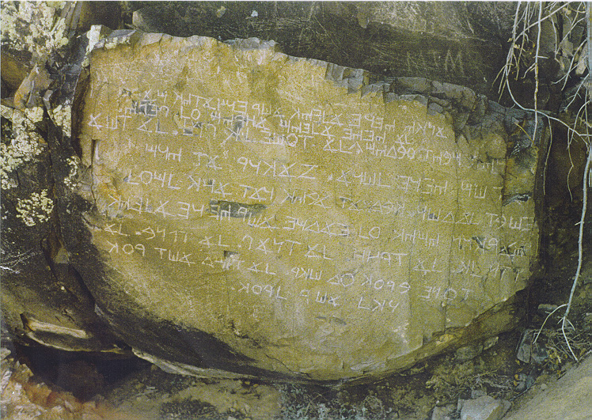
Preface
Revelation given to Yaroslav Kazmin, on June 1st 2011
Behold, MY Aryan son, I AM MICHAEL-ADAM, thy Father and God. Hear MY words about the ancient inscription on that stone which is known in the modern world as "Los Lunas Stone".
And it came to pass that I did not bless the secular scholars from MY Heavens and so they were not able to translate the inscription on the "Los Lunas Stone" and it was the totally false assertion that the inscription is Hebrew and that it is the so-called "Decalogue".
MY son, that inscription was made by the own hand of the mighty Royal Patriarch who lived after four generations from MY great son Moroni and he was the lineal blood descendant of Moroni.
Now you will send the photographic image of the "Los Lunas Stone" to My beloved son Samuel Warren Shaffer and, behold, he has the same holy authority as that ancient noble Royal Patriarch.
And My beloved son Samuel Warren Shaffer will translate the inscription and the full account of that Royal Patriarch for the benefit of the absolutely loyal members of the Patriarchal Order of the Church of Christ.
I AM MICHAEL-ADAM, thy Heavenly Father, in pleasure when you look for the Nordic Mormonism and that is the great aversion for me when the inhabitants of your Earth look for the darkness known among the so-called "LDS-people" as Lamanites.
Remember always, that I AM absolutely Pure White and thy Heavenly Mothers are the absolutely same also.
Even so, and MY blessings upon MY loyal Aryan sons and daughters of the Divine Light ever and forever, amen.
The Las Lunas Stone
Translated by Samuel Warren Shaffer
1. My name is Barnali and I do make a record of my sojourns and revelations during the course of my days.
2. I did for a time strictly obey all of the lesser laws and commandments which are of this world, insomuch that through my faith I did attain unto communion with the Spirit of the Lord, wherefore the Spirit did begin to enlighten my mind and quicken my understanding.
3. Wherefore it happened that I did perceive that salvation did rest beyond the carnal commandments, insomuch that I did understand that one is saved through knowledge.
4. And now I did liken this unto a butterfly hatching from a cocoon, for the cocoon is the lesser law and after the butterfly hath been locked within it for a time developing within itself, then it bursts out of that old law and becometh a new creature being governed by new laws.
5. Now those butterflies which remain in their cocoons must perish, and many do call from their carnal cocoons saying, behold ye are out of the way, you have sloughed off the commandments of your God! Yea ye are as a wicked Babylonian.
6. And now at this time the butterfly can see the whole world and see that it is nothing but death to return unto their cocoon, and that those wicked insects which have been termed Babylonians are simply evil bugs that live outside of the law without knowledge.
7. And now man is saved by knowledge and he cannot learn the difference between good and evil within the confines of the carnal law.
8. Wherefore judge a master not if he is doing things against the law, for the law is only a school master made to teach discipline; so that when one becomes free he can judge soberly.
9. And behold it happened that one day I was sorrowing before my God that the darkness was completely overtaking the land, which was the first home of the Aryan race in this round of history.
10. And now the Lord did say unto me, Barnali sorrow not for all things in this world are in a state of transitoriness.
11. Then I cried unto the Lord saying, oh but my Father will the pure race disappear from this world completely?
12. And now the Lord did say, Barnali believe ye not in the Resurrection from the dead? Whereupon I did say, yea Lord I believe in the Resurrection.
13. Now the Lord did say, Barnali then fear not, for every fruit hath infinite fruits within it. Yea every seed hath a million trees within it, yea more; even trees without number.
14. Barnali thou hath received the mysteries of the Resurrection and therefore ye shall also be as a tree bearing the seeds of life, each one containing infinite seeds within themselves.
15. Yea look at the stars, thou shalt have a continuation of the seeds forever. Wherefore have no expectation and ye shall have no sorrow.
16. Now when I had heard these words I was comforted, and it came to pass that as I traveled in the land I even perceived that I should help in the evolution of the lesser races.
17. For behold I had a promise that mine race would continue on all the worlds forever; wherefore I no longer had fear to donate unto the lineages of the lesser ones.
18. Wherefore I did go unto place to place and did offer my services as a lover and as a donator, insomuch that many gladly received me that they might have lighter children. Yea and I did also pick the fairest out of them and did have many relations with them.
19. And now I did have intercourse with many men’s wives and with their daughters insomuch that I did donate much seed unto that race that peradventure they might be more light and thus more intelligent so that they could improve their lives.
20. And now I did finally return unto mine own lands and I did find an Aryan wife that was pure and beautiful beyond description, she being one of the few left in the land, wherefore I did ask permission of the one husband she already had insomuch that I did help him make love unto her, and did teach unto them the perfect forms and signs of love, which is the heavenly Tantra.
21. And now I did teach unto them the mysteries of the skies and we did also build many buildings being great stone masons and workers of mortar. Wherefore I end my account and say unto all, judge not the enlightened ones who have overcome the law; whether they make love to many women, or to animals or they love those of the same gender or if they eat bugs, or drink much, or go about naked or do anything ye find to be abhorrent; for if ye are in the cocoon ye cannot perceive the true reality of things.
22. For those who are enlightened shall only do that which is positive and kind unto the human race, they understanding all of the laws of Karma and continually working for the enlightenment of man.
23. Wherefore I say unto all fare-well and may ye be faithful unto what the Lord shall reveal unto thee and meet me in the glorious resurrection full of everlasting Aryan seeds forever.
Heil the Lord of Lights and his Truth Forever!

