The Admonition of Thanlil
A South American Inscription
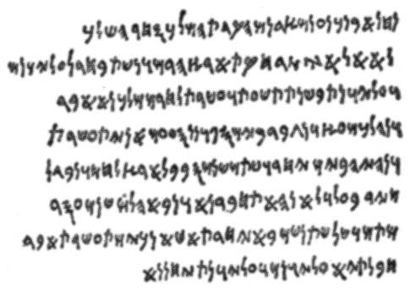
Translated by Samuel Warren Shaffer
My Son Dothrin be sober for thou art the Son of Thanlil, stand up unto the position you were born to fill and be a man; crossing yourself from all wickedness and covenant to fulfill all of your duties. Also gird up your loins for in a man’s belt is his strength. Restful are the ultimate paths of honor and joyful are the wages of wisdom and understanding. If ye know yourself ye shall never be ensnared by the arm of ruin. I say arm instead of cord because ruin is not just a cord that can be cut but it hath an arm, for it is a power which always actively seeks the destruction of the people.
The Kings have been raised up for their people; the people were not raised up for their Kings. The King shall be the arm of their strength and the face of their courage. The King is the servant of his people and the people serve him in order that he might better serve them. In the beginning God made Kings to preserve their people in every crisis and to lead them unto prosperity in every time of abundance. A King should neither lament that his times are the times of trouble nor should he grow restless in prosperity. Kings were raised up to serve their people, not to envy the times of others.
The Kings men are his brothers and comrades, he shall only put their lives in danger to save the lives of his people, and the King shall ask nothing that he would not do himself if put in the situation with no other alternative but to do it himself. Now I shall speak unto you somewhat about the Kingly Priesthood.
When ye are washed, clothed in the Royal Garments and Anointed a King ye are a King in the Eternal worlds, anointed and ordained to join thy fathers in the halls of the Ancients, but behold ye are not the King of your people until they shall acknowledge thee with a salute.
And now they shall hail thee with a salute and make an Oath to uphold thee as long as ye maintain the principles of righteousness. And as they make the Oath they shall put the tips of their fingers together with their pinkies and thumbs extended that they might see the shape of the heavenly creature through the steeple of their hands. And now righteousness is to put the interests of your own people before any other people. And now thy people are of one nation and of one race and if other nations and races shall try to come upon your lands ye shall cut them down and even wall up all thy defenses for the inheritance and culture of thy nation is the highest priority.
Those who promote other people having rights in thy nation or if they say there should be treaties of nations, yea all those who shall take any active part in subjugating thy people to other nations have committed treason and should be put to death. And now this applies unto the King also, for when a King no longer solely defends the interests of his people he hath committed treason and his people have the right to take up their arms and put him to death.
Oh be a righteous King my Son and the right to rule shall be bestowed upon thee not only by the Voice of your people but also by the very heavens above. And now once ye are washed, dressed and anointed ye shall also be given a golden ball which is a director and a balancer of the powers of understanding and wisdom, and ye shall be also given a scepter which is a sign of your power.
Yea ye shall then have power to call the court of the King and if ye follow the basic principles of righteousness the heavens shall bestow upon thy head Wisdom and Understanding, and ye shall be able to balance it in temperance and propriety in all things. May thy reign be long! Amen.
Now Dothrin was crowned over the Kingdom of the Nephtaleem and his days were glorious and prosperous insomuch that he attained much wisdom of the arts and of the stars and he executed justice and righteousness all his days.

